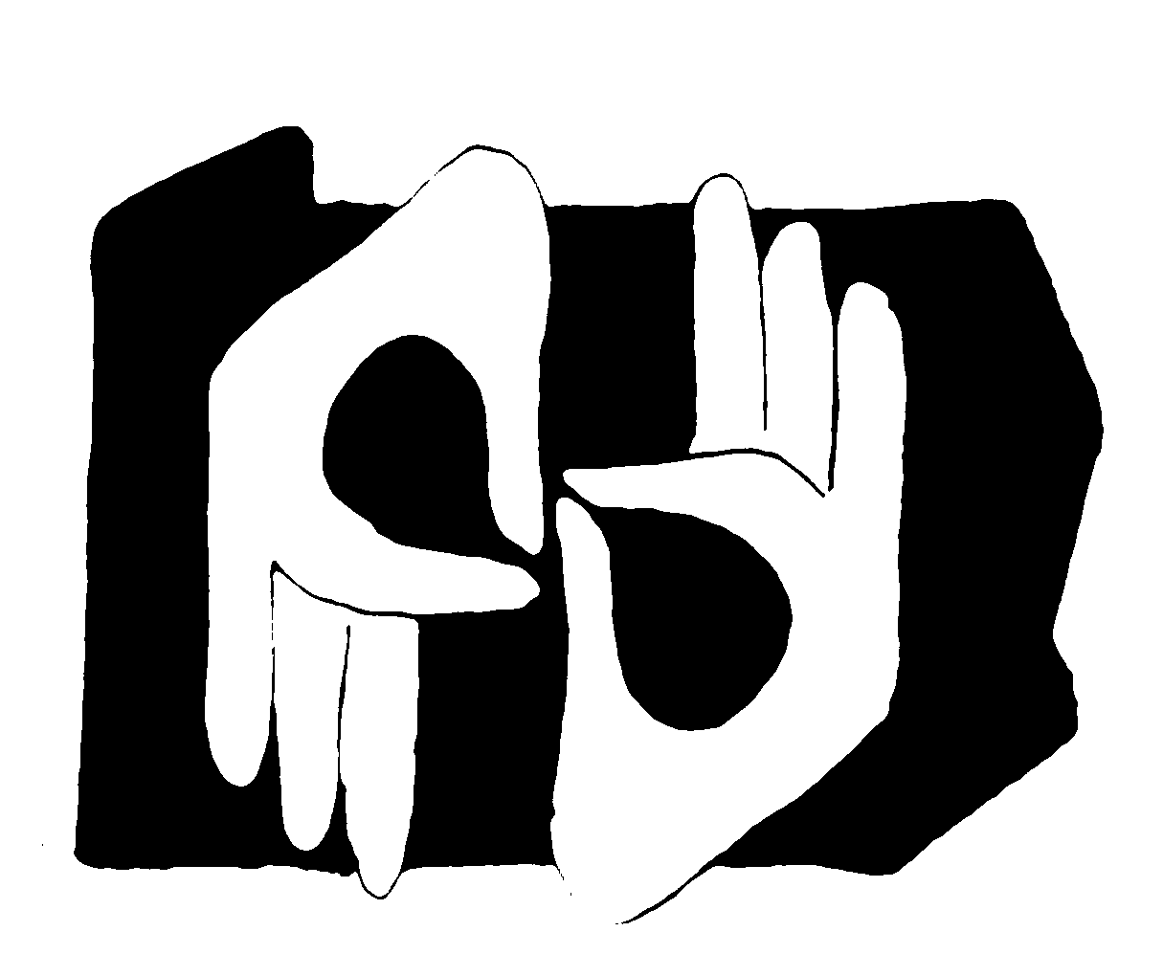 | PARID Membership Form  Fiscal Year July 1, 2015 to June 30, 2016  Send completed form with check made payable to “PARID” to:  PARID Membership  1784 East Third Street  PMB # 110  Williamsport, PA 17701 | For Office Use Only  Date Received  Date Processed

Print legibly and complete ALL sections.
Name RID & NAD Certification(s)
Address County of PA
District of Residence
(See district map on back of form)
Phone v / tty / fax / vp Email
Newsletter Electronic (default) Paper Membership Renewal Electronic (default) Paper

Membership Fees
Circle the amount in the correct category.
Postmarked June 1 – June 30  Voting Members 1 Year 2 Years 3 Years  Certified $30 $60 $80  Associate $30 $60 $80  Non-voting Members 1 Year 2 Years 3 Years  Student $20 $40 $50  Supporting $25 $50 $65  Organizational $100 $200 $280 |  |  | Postmarked July 1 – May 31  Voting Members 1 Year 2 Years 3 Years  Certified $40 $70 $90  Associate $40 $70 $90  Non-voting Members 1 Year 2 Years 3 Years  Student $20 $40 $50  Supporting $35 $60 $75  Organizational $110 $210 $290
Payment  Information | $ Membership Fee  $ Donation  $ Total Enclosed |  |  | Payment  Method |  | Cash Payment  Check or Money Order Number
Demographic Information This information is used for statistical data.
I want to volunteer to assist PARID, please contact me  By phone  By email |  | Select your interpreting specialties  Business  Community  Government  K – 12 Education  Legal  Medical  Post Secondary Education  Video (VRI or VRS)  Other |  |  | EIPA Scores of 3.5 or Higher  Select All that Apply  Elementary  Secondary |  | Select One  Female  Male | Select One  Deaf  Hard of Hearing  Hearing
Select All that Apply
State Registered
Provisionally Registered
AOPC Certified
Allow 4 - 6 weeks processing time.
A receipt will be sent to you. Your information will automatically be forwarded to your District Representative. To vote at the PARID annual membership meetings you must be a voting member of PARID and a member in good standing of RID, Inc.

On-line payment is available. Go to www.parid.org for more information.

PARID Membership Information

Voting Members
Certified Member: Any interpreter or transliterator of American Sign Language and/or English currently holding a valid certification accepted by the Registry of Interpreters for the Deaf, Inc. (RID).

Associate Member: Any individual who is actively engaged in the interpretation of American Sign Language and English and/or the transliteration of English, but who does not hold valid certification accepted by the RID.

Non-Voting Members
Student Member: Any individual currently enrolled in a course of study in interpretation of American Sign Language and English and the transliteration of English, who does not meet eligibility requirements under Certified or Associate membership.

Supporting Member: Any individual with an interest in supporting the purposes and activities of the organization, who does not meet eligibility requirements under Certified, Associate, or Student membership.

Organizational Member: Any organization/institution with an interest in supporting the purposes and activities of PARID.

PARID District Map  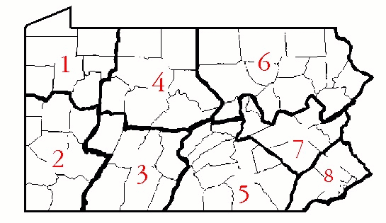 | PARID Districts by County  District 1 Clarion, Crawford, Erie, Forest, Mercer, Venango, Warren  District 2 Armstrong, Allegheny, Beaver, Butler, Fayette, Green, Lawrence, Washington, Westmoreland  District 3 Bedford, Blair, Cambria, Fulton, Huntingdon, Indiana, Somerset  District 4 Cameron, Clinton, Centre, Clearfield, Elk, Jefferson, McKean, Potter  District 5 Adams, Cumberland, Dauphin, Franklin, Juniata, Lancaster, Lebanon, Mifflin, Perry, Snyder, York  District 6 Bradford, Columbia, Lycoming, Lackawanna, Luzerne, Monroe, Pike, Sullivan, Susquehanna, Tioga, Union, Wayne, Wyoming  District 7 Carbon, Berks, Lehigh, Montour, Northampton, Northumberland, Schuylkill  District 8 Bucks, Chester, Delaware, Montgomery, Philadelphia
Membership Benefits
- Access to WWWorkshops in PARID’s SWAP Library
- Complimentary CEU processing for PINRAs, Academic Coursework, Independent Studies, and events sponsored by organizational members, PARID, PARID Districts, PSAD, PaTTAN, and PA-ASLTA
- Quarterly paper or electronic newsletter
- Reduced PARID Workshop and Conference fees
- Opportunities to network with peers at professional development events
- Email updates regarding RID, PARID, and Pennsylvania Legislation
- Organizational members receive additional benefits. Contact the Corresponding Secretary for details.

PARID is an Affiliate Chapter of the Registry of Interpreters for the Deaf, Inc.

