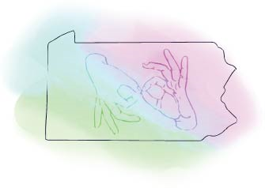
Attendance Verification Form for PINRA

Participant Information
Name as it appears in RID
RID Member #
Email Address
Phone Number

Activity Title

Dates and Times You Attended
Activity Date | Start Time | End Time | Total # of hours excluding lunch and breaks
Total contact hours for CEUs

I certify that the above information is correct.

In Person Events
Presenter/Coordinator’s Name
Presenter/Coordinator’s Signature

Virtual Events
I, |  | self-certify that I attended/completed this online event.
Participant’s Signature

Documentation is due to CMP@parid.org within 15 days of completion of the activity.
- Completed verification form
- Copy of the event agenda with times, if available
- Copy of one page from a handout received while at the event or a screenshot of the event
- Certificate of attendance

