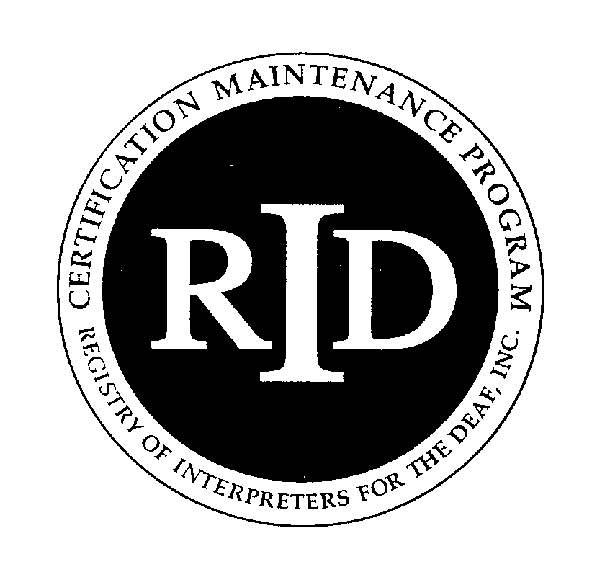



**PARID District 7 Presents:**

**Show Me The Music**

Presented in English

Presented by **Molly Bartholomew**

Lehigh Valley Center for Independent Living

713 N 13th Street

Allentown, PA

Saturday, December 9, 2017

9:00am – 6:30pm

This workshop will guide you through the musical theory of interpreting songs into sign language. You will learn how to analyze a musical composition, break a song down into parts, make sign choices based on musical notes & rhythm, and have an interpretation that flows from the beginning to the end of a song.

**Target Audience**: ASL Interpreters, Teachers and Students

**Educational Objectives**: At the conclusion of the workshop, participants should be able to:

* Identify basic vocabulary knowledge related to reading musical scores.
* Relate ASL sign choices to musical notes
* Locate basic rhythm patterns in multiple genres/time signatures

**Molly Bartholomew**, NIC, has had a love for both sign language and music since a young age. She started playing the flute and learned how to read music at the age of five. She continued to study different instruments as well as performed in local musical theatre productions. It was also around this time she had her first encounter with sign language. She is a certified sign language interpreter specializing in Artistic Interpreting with more than 10+ years professional experience. She provides interpreting services for the daily shows at the local theme parks, as well as concerts, special events and the cruise line industry. Molly has now turned her focus to educating interpreters and students on her musical theory and the importance of understanding music as a language. She has A.S. in Sign Language Interpretation from Hillsborough Community College, Tampa, FL and a B.A. in Communications from Southern New Hampshire University, Manchester, NH.

Register at: http://www.parid.org/event-2685950

*Reasonable accommodations must be received by 11/25/17.

Contact Kelly Deibert at district7rep@parid.org for accommodations, refunds, cancellations, and non-discrimination policy.

No refunds will be issued after 11/9/17.