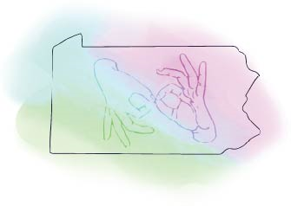
Academic Coursework Activity Report
For Courses at accredited Colleges and Universities

This activity report must be submitted to the RID Approved Sponsor upon completion of the academic course.
A copy of the description of the course and the Institution's transcript or grade report should be attached. The Sponsor will file the paperwork online at www.rid.org for CEU processing at the RID national office.

Participant Information
Name as it appears in RID
RID Member #
Email Address
Phone number
RID CEU Cycle End Date

Course Information
Course Title
Name of College or University
Is the course calculated as quarter-credit hours or semester-credit hours?
What is the number of credit hours assigned to the course?
Course Start Date
Course End Date

As a CMP participant, I certify that this academic coursework represents a valid and verifiable Continuing Education experience which exceeds routine employment responsibilities.
Name printed | Signature | Date

CMP Coordinator Section

Name of Approved Sponsor: |  | Pennsylvania Registry of Interpreters for the Deaf (PARID)
Activity Number: | 0045
 | Sponsor Code |  | MM/YY | Ascending within month
Workshop ID

Content Area (select one) | Specialty Content Area (select all that apply)
General Studies (GS)  Professional Studies (PS) | Legal  Power Privilege and Oppression (PPO)

Total number of CEUs to be awarded to participant:
1.5 CEU/credit based on a semester session or 1.0 CEU/credit based on a quarter session.

As the CMP Approved Sponsor for this Academic Course activity, I have verified successful completion of the course and a grade of “C” (2.0 GPA) or better and the course was taken at an accredited institution recognized by the Council for Higher Education Accreditation (CHEA).
Name printed | Signature | Date

