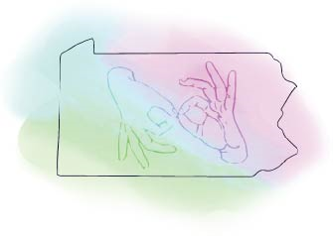
Independent Study Plan

This Independent Study Activity Plan must be approved by an RID Approved Sponsor
PRIOR to the onset of the activity.

Participant Information
Name as it appears in RID
RID Member #
Email Address
Phone Number

Complete the following questions to describe the proposed Independent Study.

1. What do I want to do?
Describe the activity you are proposing
(Ex: I would like to know more about the process of translation from a linguistic point of view. Several books on translation have been recommended. I would like to read them and apply them to my work.)
Enter information here:

2. What are my specific goals?
Keep your goals measurable, observable, tangible!
(Ex: “I will compare the problems and techniques of spoken language interpreters to those I have experienced.”)
Enter information here:

3. How will I show my sponsor what I learned?
Describe your evaluation process.
(Ex: I will write a 1-2 page report comparing spoken and signed translation work.)
Enter information here:

4. How many CEUs am I proposing and why?
Remember, in an educational setting, 10 contact hours = 1 CEU. Non-traditional activities should follow a different ratio. A maximum of 2.0 CEUs can be earned for each project. (Larger projects may be broken into components and each component filed as a separate independent study project earning up to 2.0 CEUs each.)
Enter information here:

5. When will this proposed project start and end?
Project may begin only after approval from the Sponsor. Project must be completed within twelve months.
Enter Information here:

I agree to implement the Independent Study Activity as outlined in this plan and to submit all the necessary documentation of successful completion to my Sponsor. I certify that this activity for CEU credit toward the RID CMP requirements represents a valid and verifiable Continuing Education Experience that exceeds routine employment responsibilities.
Name printed | Signature | Date

CMP Coordinator Section

Date ISP approved and by whom
PARID member
# of hours
Hours to CEU Ratio
# of CEUs awarded
Activity Number | 0045 -
Workshop ID

I will ensure that this Independent Study Activity will be overseen and evaluated by individual(s) with the relevant expertise. I, or my designee, have discussed the Independent Study Activity outlined in this plan with the participant and agree that it represents a valid and verifiable Continuing Education Experience. Further, I or my designee, agree to assess the documentation submitted to me by the participant upon completion of the Independent Study Activity and award CEUs if completion is satisfactory.
Name printed | Signature | Date

List of Supporting Documentation | Date Received

